AngularJS Testing:

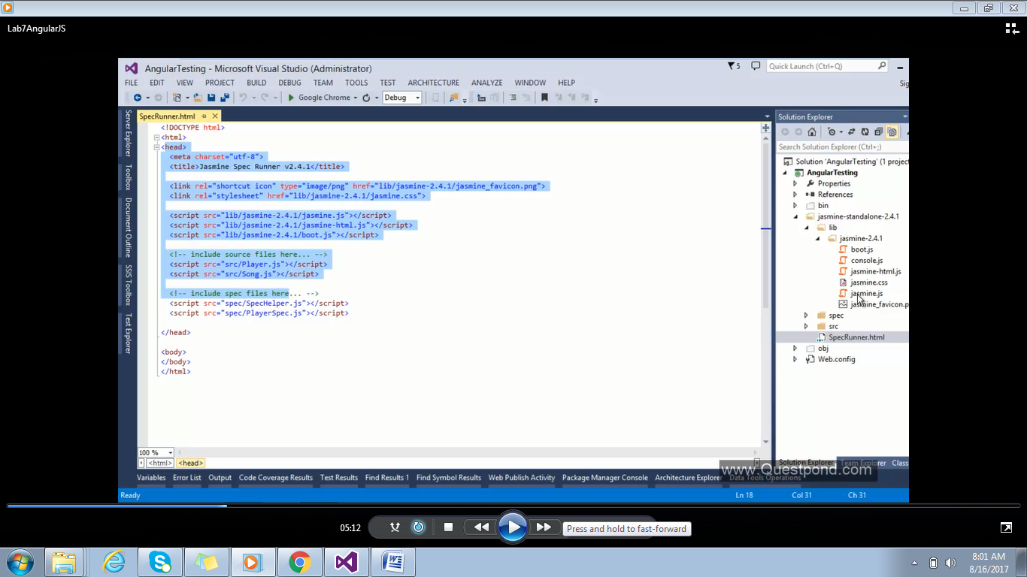

Src folder : To keep the JavaScript files

Spec : All the test files should be placed in spec folder

Create a file

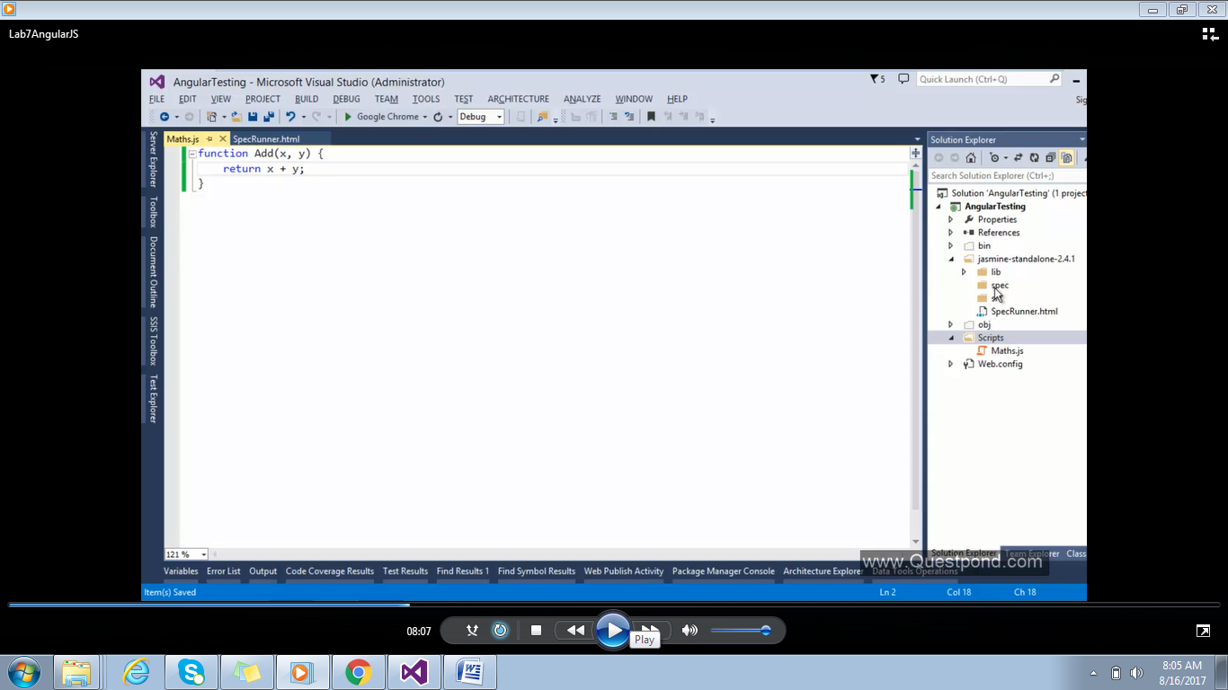

Create a MathsSpec to test the maths javascript file:

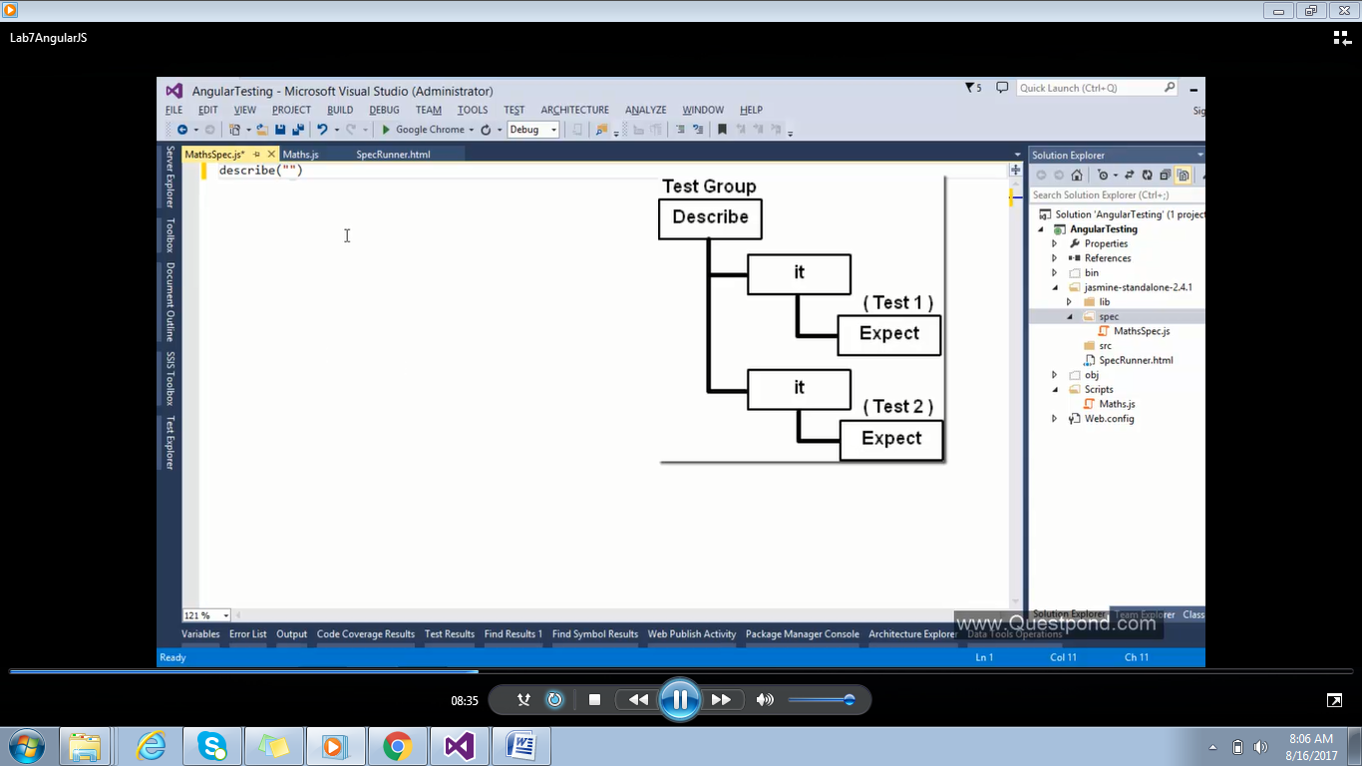

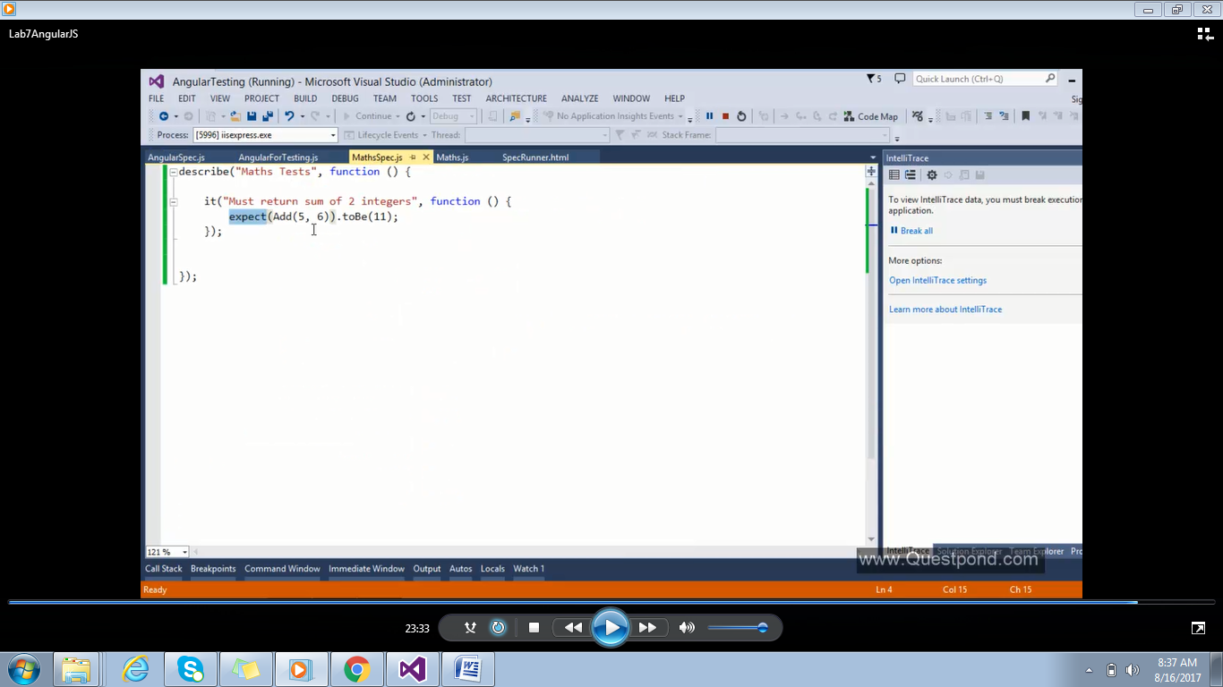

Refer maths.js and mathsSpec.js file in to the Spec runner:

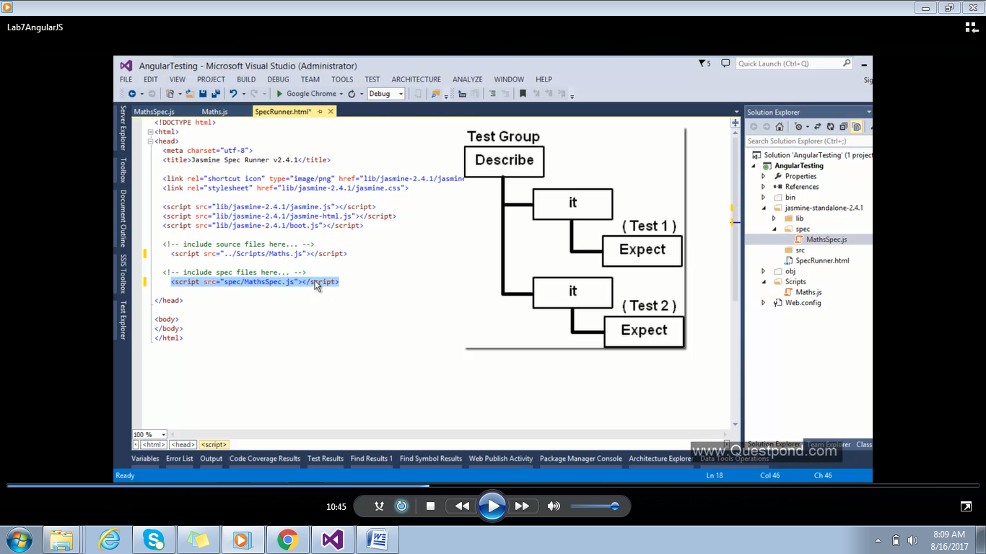

Down Load AngularJs core for Angular testing form nugget package.This will provide

AngularJsmock files to test the AngularJs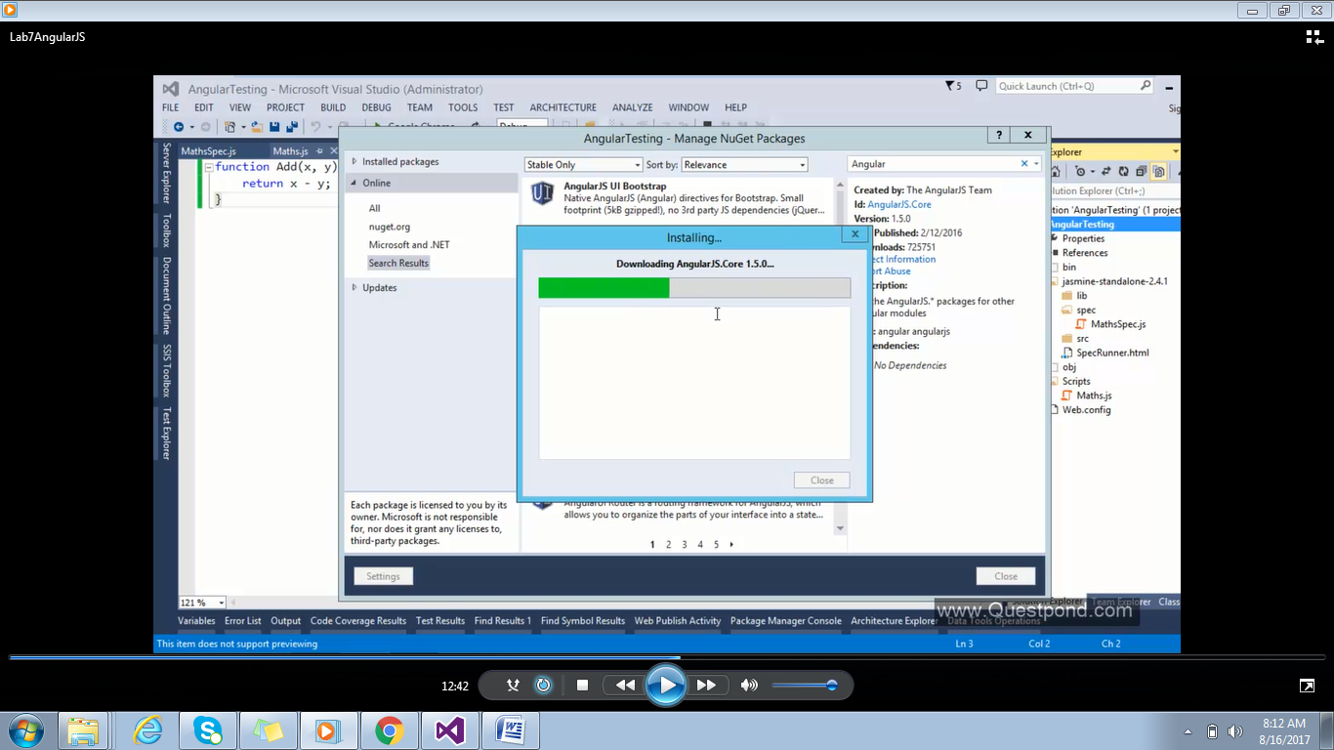

Add JavaScript file AngularForTesting:

He 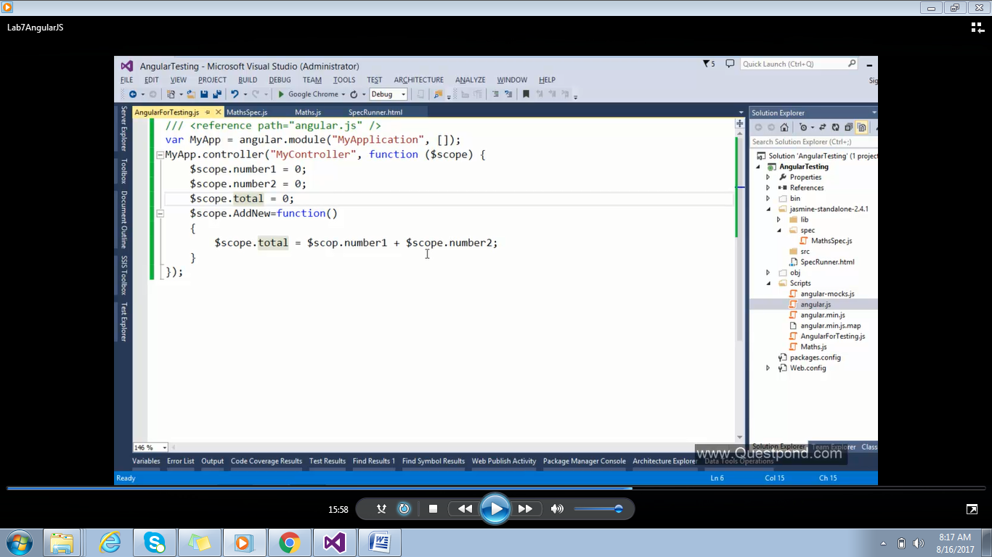

Create AngularSpec.Js file to test test the AngularforTesting code.

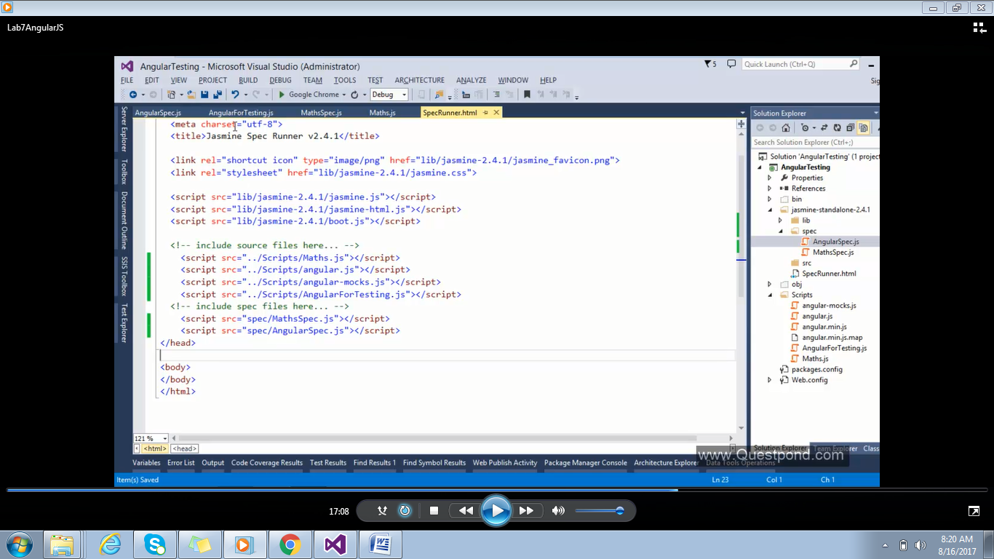

Write the code to test using mock object.

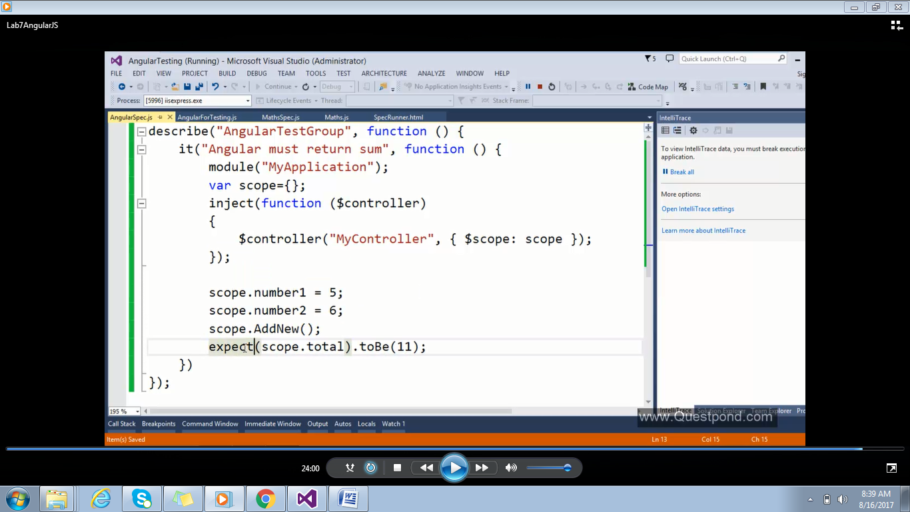

Execute for the results:

